www.pukekohetrampingclub.org.nz
The Bush Telegraph

Next meeting: 6th Nov 2023 @ 7:30pm
Venue: Anglican Church Hall, Wesley Street – Pukekohe

Supper Duty: Frances Gibbon
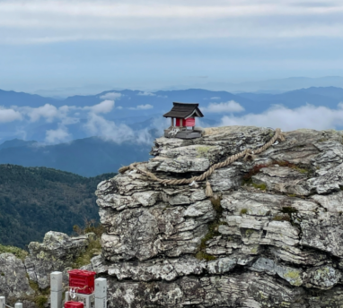
Guest Speakers: Rebecca Banks - Three of our members had a wonderful time hiking, sightseeing and food-sampling in Japan last month. Come along to learn all about their fantastic trip.
Heads up: for the December meeting ( another reminder will go out before hand)
There will be No Guest Speaker - Xmas Mix n Mingle night.
This year LADIES, you have the pleasure of providing supper.

New Members – None for this Month
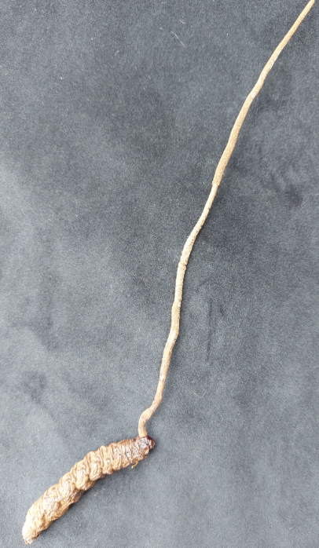
“Where am I competition” or what am I?
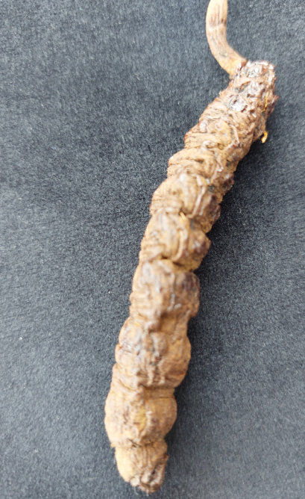
Barry has gruesome story to tell about with these photos:

President Notes

Another month is wrapping up and we have passed the labour long weekend which signals outdoors season for New Zealand. I hope everyone enjoyed the long weekend and avoided the terrible traffic jams some of my colleagues were stuck in for up to 7 hours.
The schedule for October had a few gaps, it was fortunate for us Anne and Owen Porter led a walk in Waiuku forest and discovered the Franklin Endurance Riding Club had put up extremely clear trail markers for their competitions. There are currently several options for walkers to utilise until the markers come down.
- Trail A = 25Km included both South & North side forested areas, plus Port Waikato / River mouth lookout
- Trail B = 20km included both South & North side forested areas, plus Port Waikato / River mouth lookout - The North side extension is out & back, so you can just go to lookout & turnback
- Trail C = 15 Km - stays within South side, and loops whole area
- Trail D = 10km
- Trail C = 6km
- Trails A & C together is the 40Km Endurance route for their elite competition, for off road runners
Directions to the start can be obtained from Barry if required.
More good news about tracks from the FMC newsletter,
Phased opening for Kaimai tracks
Following extensive testing, the Department of Conservation has not found any further kauri dieback on the central Kaimai tracks that were closed in the vicinity of the original find.
Most closed tracks and all huts are expected to be open again by Labour weekend.
Two tracks - the Wharawhara Tramway track and the Te Rereatukahia Hut track from near the hut of that name to the Wharawhara Tramway track remain closed for a few more months pending further tests being done. Te Rereatukahia Hut will be accessible from the Tuahu and North South Tracks, coming from the south, and from the north it will be accessible via the Old North South Track from Waiorongomai / Pylon Peak.
Intending users are advised to monitor the DOC website for further updates. Read more on the DOC website.

Kaweka Road access to the Kaweka Forest Park, is now open for 4WD vehicles only as the road is still settling. It’s great to hear some positive news around backcountry access for a change and that progress is being made by DoC. Sadly, Lake Waikaremoana still has significant repairs required. There is a proposed opening date of 10 January at this stage.
Another interesting item from the FMC newsletter was around a very creative and festive approach to the wilding pine issue in the Christchurch area. Connect Hununui are looking for volunteers to help fell wilding pine to be sold as an environmentally friendly alternative to farmed Christmas Trees. That is a bit of Christmas magic if you ask me.
I am very excited that kiwi’s favourite election, Forest&Bird’s Bird of the Year is kicking off on 30th October. This year they have included 5 extinct birds and are looking for Bird of the Century to celebrate Forest&Bird’s 100th birthday. After enjoying copious birdcalls in the Hunuas last weekend it was made very clear the impact all those years of pest control are really paying off, and how important it is we continue and build on this and raise awareness so we don’t lose any more. Do check out the website birdoftheyear.org.nz/ and get behind your favourite bird/s this year, the campaigns are always great fun.
Lastly for our cyclists, the Counties Cycle Classic is taking place on Sunday 12th November at the Otaua Hall on Maioro Road south of Waiuku this year. The course will have magnificent views of the mighty Waikato River. More information here raceroster.com/events/2023/79852/counties-cycle-classic .

Becky.

Future Trips – Programme
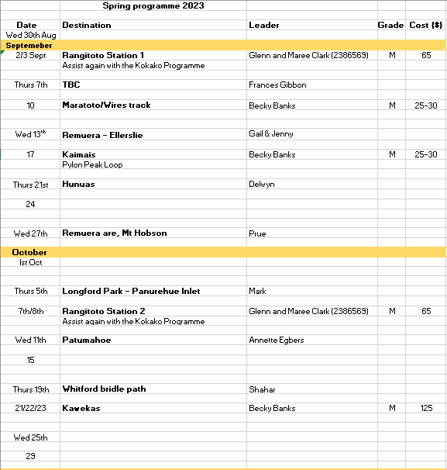

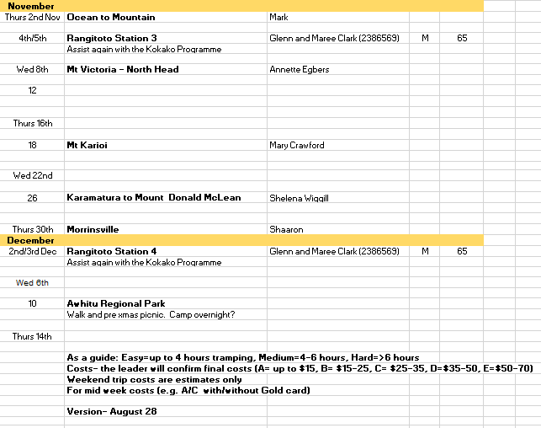

Trip Reports

Trip Report – Gatland Hilton Visit – Sun 22nd Oct - Hunuas
Attendees – (9) - Barry, Becky, John J & new neighbour Jennifer from USA, Anne & Owen, Janette, Terry, Shannon,

Departed 0800, parked at camp ground carpark, walked up onto & across dam (which was almost 100% full so good news with summer about to start), up Lilburne Rd to Piggotts Camp for break, onwards followings Ernie Track, past the seat with a view, turn off on to Upper Mangatawhiri Track, past Mine Rd track junction and on to Hut turnoff along one of baiting side tracks to hut in time for lunch.
Small 2 bunk Garden shed converted into basic hut, kitchen bench, gas cooker, with covered balcony & water tank / handbasin – called Gatland Hilton by the Kokako volunteers. Used mainly by Bird Survey teams. Surrounded by old bush.
Was in good condition, after lunch we did sweep up of balcony, carried home some rubbish & headed back retracing our steps, with stop at Piggotts again..
No Kokako song this trip (Rosemary says probably busy nest building and keeping low profile) but compensated by large amount of Kaka activity, saw one low down in tree over track, a number talking away in trees above us, and lots flying about making lots noise.
Campground was very busy with many family groups in tents for Labour weekend, but tracks quite quiet, meet 3 others at Piggotts & another solo guy on track, all heading for Kohukohunui Trig/Lookout, plus on way home, meet 1 family doing Ernies enjoying the seat with a view.
9 Km from carpark, 625 metres climb and 4 hours each way.

On page 29 of the Hunua Kokako Recovery Project booklet, I found the following sentence

Gatland Hotel can be found on the far side of the KMA, across the river on MA line. It was intended for use as another base from which to do bird work such as surveying. Due to her efforts preparing the hut and the site, it was named Gatland Hotel after Rosemary and is normally referred to as the Gatland Hilton. The lean-to at the front of the hut was built with the help of Rosemary’s parents, who were the first people to stay in the hut while Rosemary camped nearby.

Ex PTC Club member & ex DOC Ranger Rosemary provided additional instructions to assist our “hunt”

Bridel Path, Whitford. 19 Oct 23.

Suspicious looking group armed with walking sticks observed! We were getting ready to start our walk from Potts Road reserve when a Security van arrived. They were checking unusual activity. Having decided that we were not a threat they drove off.
With temperatures rising and the humidity high, we stopped several times on our walk to refresh our body fluids. We also took the time to observe the humongous houses that surrounded the area.
Lunch was originally planned at the beach. However, in view of the hot conditions and lack of shelter, it was decided to stop earlier at a shady spot beside the path.

After lunch we continued along the path checking out the large areas of mangrove trees and the beach. We came across several wading birds and their newly hatched chicks. A number of properties we walked past had horses in little paddocks.
On the last leg of our walk, a car went past, then turned around and drove past us for a second time. The driver took a close look at us as if looking for somebody! Who was it? Why! A similar event occurred before lunch break on another road. There were a number of security cameras located on the lamp posts in the area. I am sure all our movements were closely monitored and recorded for future reference. Perhaps the hot day was making my imagination go wild!
We made it safely to our cars without further interruption and in no time at all, we were at the Brickworks Café in Whitford village. The owner was more welcoming than the other lot and quickly had our cakes, coffee and cold drinks on our table. Perhaps it was because the till was ringing.
Thank you everyone for turning up for the walk. It was an enjoyable day and great company.

Shahar

Report on Wednesday October 11th walk

Twenty eight walkers enjoyed the 7km walk around the Patumahoe area. Walking the local streets allowed everyone to enjoy the Spring blossoms of the cherry trees lining the road. We explored the waterways and streets before taking the route to Henry’s Reserve. Over stiles, through muddy water, through gates, past cattle until we reached the Reserve to have a well earned lunch by the stream below the waterfall. Then back upHunter Rd and through the new subdivision to our cars. Coffees enjoyed at the Bar n Grill in Patemahoe
Annette Egbers

Pahuehue inlet October 5th

Once again the weather gods smiled on the mid weekers.
We bussed to the Longford Park Retirement village. From there we were lead in circles through reserves and side street of Longford Park. After a steep down hill section it was time for morning tea on a deck that gave us a great view south over the inlet. There was requests for the tide to come in and the sun to come out. Our skirting of the inlet continued until we appeared out of the bush beside a polling booth. After that we street bashed till lunch on the eastern side of the inlet. There was a flying fox and swings for the young at heart. The only down side was the Police eagle helicopter that kept us under constant observation. As far as possible we stuck to the foreshore until Pahurehure. We got a great view to the north as we crossed the pedestrian bridge to Harbourside where half headed for pergola seating and a 30 minute wait for the bus. The caffeine addicts did 500 meters for their fix. Having enjoyed it too much another 2.5 km as they missed the bus.
10 km. ( Caffine Addicts 13 km )

Remuera/Mt Hobson walk 27 Sept
Nineteen of us met on a cool and blustery Wednesday. For a change it wasn’t wet. We trained to Remuera station and headed up Mt Hobson. We were going to have morning tea there but it was just too windy. We headed down to Remuera Rd and met Hamish and Joan who had decided not to traipse up the mountain
From there we tiki toured down Ridings Rd through to Buttle, Arney, Wiles, Hapua before emerging onto Shore Rd for morning tea. After that we continued along Shore Rd where I took them on a dog leg around Portland Rd, up Ingram then into Spencer St and out onto Victoria Avenue through the school. Carol left us here to take the bus to Newmarket and home.
We had lunch at the beach at the bottom of Victoria Ave then it was around the boardwalk, through Martin Wilson Field, Lingarth St and Combes Rd to the Waiata Reserve. We climbed up through the reserve to the Remuera shops for a welcome coffee before the final 1.4kms to the train at Greenlane.
I enjoyed the walk but there were quite a few hills. Sorry guys but that’s Remuera for you!
Prue B
Wairoa Loop Track 21st September
A group of 18 plus two dogs meet at the carpark at Otau Rd, off Moumoukai Rd in the Hunuas.
It was a short walk to the morning tea spot at the picnic area below the Wairoa Dam. We continued up the road to one of the Wairoa Track entrances. It was a steady climb of about 300 m up to Repeater Rd with six members opting to do the side trip to see the lookout. After arriving at the Repeater Station, we continued down Repeater Rd, passing a seat that is cordoned as it is now very close to the cliff face. Then continuing the road and past the track back down to the car park, we then turned off on a short road to the Repeater Campsite. The campsite has mattresses for two people but the shelter has no door. There is a long drop toilet and two large picnic tables. As it was one of the hotter and sunny days in September, many choose to have lunch in the shade of the trees. Returning to Repeater Rd we made our way back to the track down to the car park. This track has many steps and one member of the party fell down a flight of steps just before the first bridge. Luckily no bones were broken and after applying first aid to his many wounds, he was able to walk out. This part of the track, beside the stream, had been damaged in the recent cyclone so now has two additional by-passes to climb above the damaged or washed away track. A walking time of under three hours
Some stopped in Bombay for a well deserved afternoon tea.
Many thanks to all those who helped with the first aid, having many first aid kits meant there were choices of bandages available. The Pukekohe A and E off Manukau Rd/ Glasgow St were quick to provide treatment and did an excellent job.
Leader Delwyn Connolly

Odds And Sods

Special off for Club member: Please find attached details of Tim Pankhurst of walking the Te Araroa with my wife Sue and former Wellington mayor Dame Kerry Prendergast.
Every Effing Inch will be published on Nov 8, rrp $40.
A special pre-publication price of $30 (plus p&p) is offered to your members.
It is available direct from the Underground Bookstore (theundergroundbookstore.nz) or major bookstores.

Here’s the first part of the intro that sets the scene for the walk,
It’s a winter’s day and we’re walking on a track in the pines behind Tawa, just north of Wellington. A woman on a bike pulls up beside us and asks: ‘Are you doing the Te Araroa Trail?’
‘No,’ we say, ‘We’re not, but we’re going to. We’re in training for it. We’ll set off in the spring.’
‘Are you doing EFI?’ she responds. We are puzzled. EFI? What’s that?
‘Every Fucking Inch.’
We laugh and look at each other and say yes, we guess we are.
And that was to be our mantra. Whenever the going got tough over the days, weeks, months and two summers to follow, when we were bone-weary and the temptation was to skip a dangerous piece of connecting road, or a tricky and inconvenient estuary or river crossing, we would mutter ‘EFI’. Every Fucking Inch.
Our feeling was that if you are going to walk the 3012km length of New Zealand – the long pathway – you need to be true to that, whatever the terrain.
As to why we might want to even do that, well, that was a little more difficult to answer. Most of our friends wondered if we were serious and, when we seemed so and actually set out, decided we were idiots.
One took to calling me soldier, which he explained was a slang term to describe those who spend large portions of their waking hours pointlessly exercising. This from a man with a small but perfectly formed beer gut.
‘Walk, Forrest, walk,’ laughed another.
‘The only reason I would take up walking is so I can hear heavy breathing again,’ said another. He added, ‘Walking can add minutes to your life. This enables you, at eighty-five years, to spend an additional five months in a nursing home at $7000 per month.’
My old friend Joe Bennett, consistently the country’s most erudite comedic columnist, the closest we have to The Spectator’s Jeremy Clarke, although a life not as low, offered some perspective.
At 40, it is a midlife crisis when you realise half your life is over – and that was the best bits. Tantric sex and dropping out to become a potter may seem the answer. That is, before returning to the office as usual.
But in the mid-60s, it is a late-life crisis when you realise you are shuffling forward with the crowd along an enormous diving board and the people in front have started plunging off the end into the chlorinated water of oblivion. There is no turning back, the people behind are shuffling inexorably forward.
This is when the question looms: Is that it?
Joe says there are various forms of self-deluding therapies available. Like golf.
But none of these are for me. I’m too fast for tantric sex, too uncreative for potting, and you can’t be a fisherman and play golf, which in any case is a particularly pointless exercise that no one can ever master. (Except, perhaps, North Korea’s Supreme Leader Kim Jong Un, reputed to have completed a round in 18 shots, a hole in one every time. The only person within his inner circle to voice the ever-so-slightest doubt about this extraordinary feat was strapped to a cannon, with sufficient time to consider how far and wide his remains would spread.)
So, what else to do to ward off dementia and rheumatism, while striving to avoid the business end of the diving board, but to walk?
Motoring journalist Evan Green, who took part in the Paris–Dakar Rally 40 or so years ago, wrote a book, A Boot Full of Right Arms, the title drawn from the number of people who offered up that appendage to accompany him. We would be lucky to raise the smallest pinky at the outset of our mission.
It had been my ambition to tackle the Trail from when it was first being developed and officially opened in 2011. What an achievement that would be: to walk the length of your country, explore its backwoods and byways, whistling as the pack is merrily shouldered, each day an adventure. All that is needed is a spare five months or so, or more likely more time spread over a year or two, and a lot of determination.
Retirement provided the opportunity and I would do it solo if need be. My wife Sue remained unconvinced but agreed to at least do some of it. And when our friend Dame Kerry Prendergast got wind of it, she was an immediate, enthusiastic starter. The Three Pensioneers were underway – with two dames, one with a capital D, to keep me honest. Kerry’s husband, Rex Nicholls, was a vital fourth member of the team, providing transport and support and cold beers.

Kind regards Tim Pankhurst

Gear Requirement

Day Trips:
Small pack Suitable footwear
Lunch and snacks Full drink bottle
Rainwear Hat (woollen or sun)
Gloves Small first aid kit / whistle Thermal blanket Change of clothes
Weekend Trips:
Waterproof pack large enough to hold all your equipment and food
Sleeping bag Boots
Rainwear Warm clothing eg fleece garments, polypropylene, etc
Woolly hat Gloves/mittens
Torch or headlight Thermal longs for winter trips or if above the bushline
Toilet gear Plate and mug and cutlery
Small first aid pack / whistle
If in doubt ask the Trip Leader for advice for day, weekend or longer trips. It is recommended for all trips that the NZ Mountain Safety Council’s pack liners be used. These are available from Charlie & Joy Browne (Phone 238 7298) at a cost of $4.50 each. Use of Whistle:
Please remember the whistle should be your equipment of choice to attract attention if needed. If anybody falls behind and loses sight of others, feels unwell and must stop for a rest, becomes injured, etc then the agreed call to alert the Trip Leader and others in the party is THREE (3) LONG whistle blasts, REPEATED as necessary. The Trip Leader and/or others in the party will respond with TWO (2) LONG blasts indicating they have heard and are coming to your aid. It may be helpful in some circumstances that a repeat whistle blast will allow accurate location.
Club Gear:
All Club gear is stored at Charlie & Joy Browne’s residence, Jenkin Road, Pukekohe West. All Club members are welcome to use the gear for Club and private trips (however Club trips have booking priority) – hireage to nonmembers is not encouraged. Club gear is, at all times, to be returned in good, clean condition. All losses/ damages must be reported to the Club’s Gear Custodians.
HANDY INFORMATION
Monthly Club Meeting:
The Club meets at the Anglican Church Hall, Wesley Street, Pukekohe on the first Monday of each month at 7.30pm unless otherwise advised.
Annual Subscriptions:
$25.00 single $45.00 family (two or more) Saturday/Sunday Trips:
Unless otherwise stated SATURDAY/SUNDAY Club trips leave from the carpark opposite McDonalds in Hall Street, Pukekohe. Members who wish to be picked up elsewhere must make arrangements with the Trip Leader. Leaders must be contacted by Thursday night if you are going on a Sunday trip or Wednesday night for a Saturday trip. Leaders reserve the right to refuse any member participation in any tramp not considered suitable. Online: with your surname as the reference and “Sub” as the code, to the PTC bank which is ASB Pukekohe, account number 12 3023 0324204 00
Weekend and Longer Trips:
Monday night is cut-off point. Any member who does not adhere to this will miss out. The reason for the cutoff point is to allow time for the Trip Leader to arrange, transport, food, bookings, etc.
Midweek Trips:
Contact Trip Leader for start place and time for trip.
Clarification of Trip Leader’s Responsibilities under OSH Regulations:
Only PAID (ie Commercial) group leaders are under legal Health and Safety obligation to members of that group. As all Pukekohe Tramping Club leaders are UNPAID VOLUNTEERS, the responsibility is on ALL members of the group to observe and take responsibility for their own actions.

PTC Committee 2021/2022

